Chapter 13, Problem 46.

(a) Find I₁ and I₂ in the circuit of Fig. 13.110 below.

(b) Switch the dot on one of the windings. Find I₁ and I₂ again.

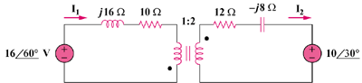

Figure 13.110
For Prob. 13.46.

